**A Project Report**

**On**

**Round Robin And Improved Round Robin**

**For**

**Operating System and System Programming Lab (15B17CI472)**

Submitted by:

**Gaurav Kesarwani (9920103186)**

**Divyanshi Sahani (9920103197)**

**Kushagra(9920103212)**

**Atindra Mishra(9920103214)**

Submitted to:

**Dr. Neeraj Jain**



**Department of CSE/IT**

**Jaypee Institute of Information Technology University, Noida**

**December, 2022**

**PROBLEM STATEMENT AND OBJECTIVE**

This project focuses on the difference between round robin and improved round robin. It focuses on the comparison based on waiting time total turnaround time the average time and all. In general round robin is one of the best ways of scheduling in itself, It removes the biggest problem of starvation hence improving the overall impact. Over here we are going to compare both the scheduling and see if one has an upper hand on the other.

**INTRODUCTION**

The primary computer resource is CPU. There are basically four main function of CPU out of which scheduling is one of them. And Scheduling is central to the operating system design. It is basic activity for multi programmed Operating system. Selecting an appropriate distribution of CPU and I/O bound programs is crucial for CPU scheduling. CPU scheduler decides which of the processes in the ready queue is to be allocated the CPU. Ready queue can be maintained either as a FIFO queue, Priority queue, tree of any other unordered linked list. CPU scheduling can be pre-emptive or non-pre-emptive type.

Round robin scheduling (RRS) is a job-scheduling algorithm that is considered to be very fair, as it uses time slices that are assigned to each process in the queue or line. Each process is then allowed to use the CPU for a given amount of time, and if it does not finish within the allotted time, it is pre-empted and then moved at the back of the line so that the next process in line is able to use the CPU for the same amount of time.

**MOTIVATION**

Main job in todays world is to be productive and fast with your work. The computer is very well sufficient in itself but small things like scheduling makes a vital effect on the working. There are various ways of scheduling but our work is to find the best and stick to oi. Here also we are trying to compare these two scheduling and trying to see which is good for us.

**OBJECTIVE**

By the end of our project we would be able to tell out of Round Robin and Improved Round Robin which is better in all grounds. Be it waiting time, turnaround time all the averages the first time the process get to the CPU everything.

**DETAILED DESCRIPTION OF THE PROJECT**

**ROUND ROBIN CPU SCHEDULING ALGORITHM**

Following is the proposed RR CPU scheduling algorithm:-

Step 1. START

Step 2. Make a ready queue of the Processes like READYQ.

Step 3. REPEAT steps 4, 5 and 6 TILL queue READYQ becomes empty.

Step 4. Select the first process from the ready queue and assign the CPU for the given time quantum.

Step 5. After complete execution of current process, removed it from the ready queue and go to step 3.

Step 6. Remove the currently running process from the ready queue READYQ and put it at the end of the ready queue

Step 7. STOP

As mentioned, Round Robin Scheduling algorithm which is used for executing the jobs on processor with a small unit of time slice. Improved Round Robin Scheduling Algorithm which is almost similar to Round Robin scheduling algorithm using time slice but little different in the execution of jobs on processor. In improved round robin scheduling algorithm we take the first process in the ready queue and execute it till the allocated time quantum then we check the remaining burst time of the running process. If the remaining burst time is less than the allocated time quantum then the running process is executed again till it finishes. But, if the remaining burst time of the running process is more than the allocated time quantum then the next process in the ready queue is executed. And we remove the currently running process from the ready queue and put it at the tail of the ready queue. Hence, the improved round robin scheduling work

**IMPROVED ROUND ROBIN CPU SCHEDULING ALGORITHM**

Following is the proposed IRR CPU scheduling algorithm:-

Step 1. START

Step 2. Make a ready queue of the Processes like READYQ.

Step 3. Repeat steps 4, 5 and 6 TIL queue READYQ becomes empty.

Step 4. Select the first process from the ready queue and assign it to the CPU for the given time quantum.

Step 5. If the remaining CPU burst time of the currently running process is less than allocated time quantum then assign CPU again to the currently running process for remaining CPU burst time. After complete execution of current process, removed it from the ready queue and go to step 3.

Step 6. Remove the currently running process from the ready queue READYQ and put it at the end of the ready queue.

Step 7. STOP

**IMPLEMENTATION**

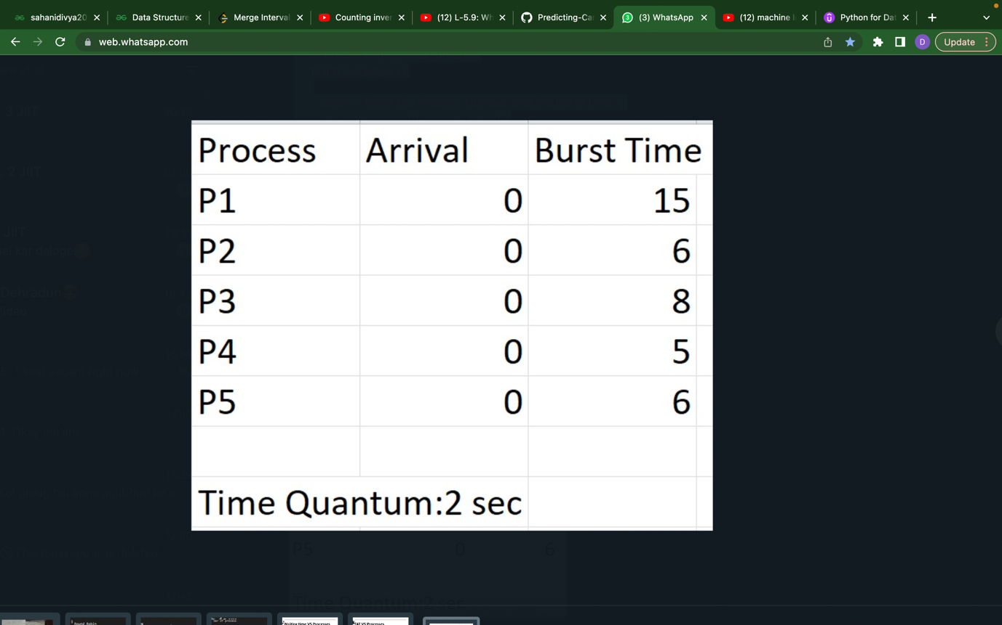

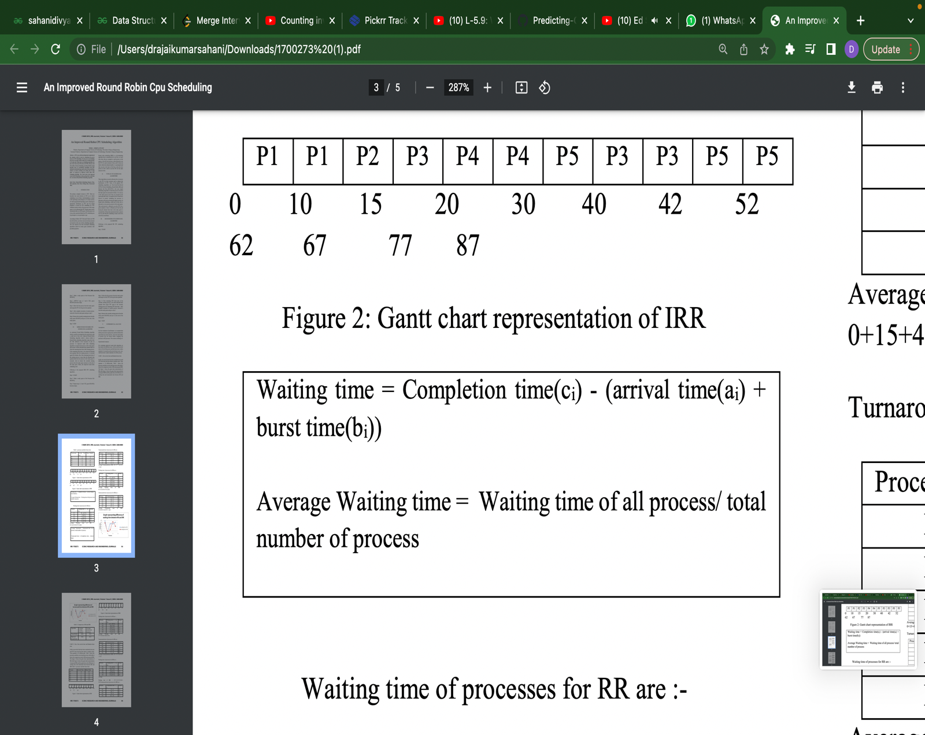

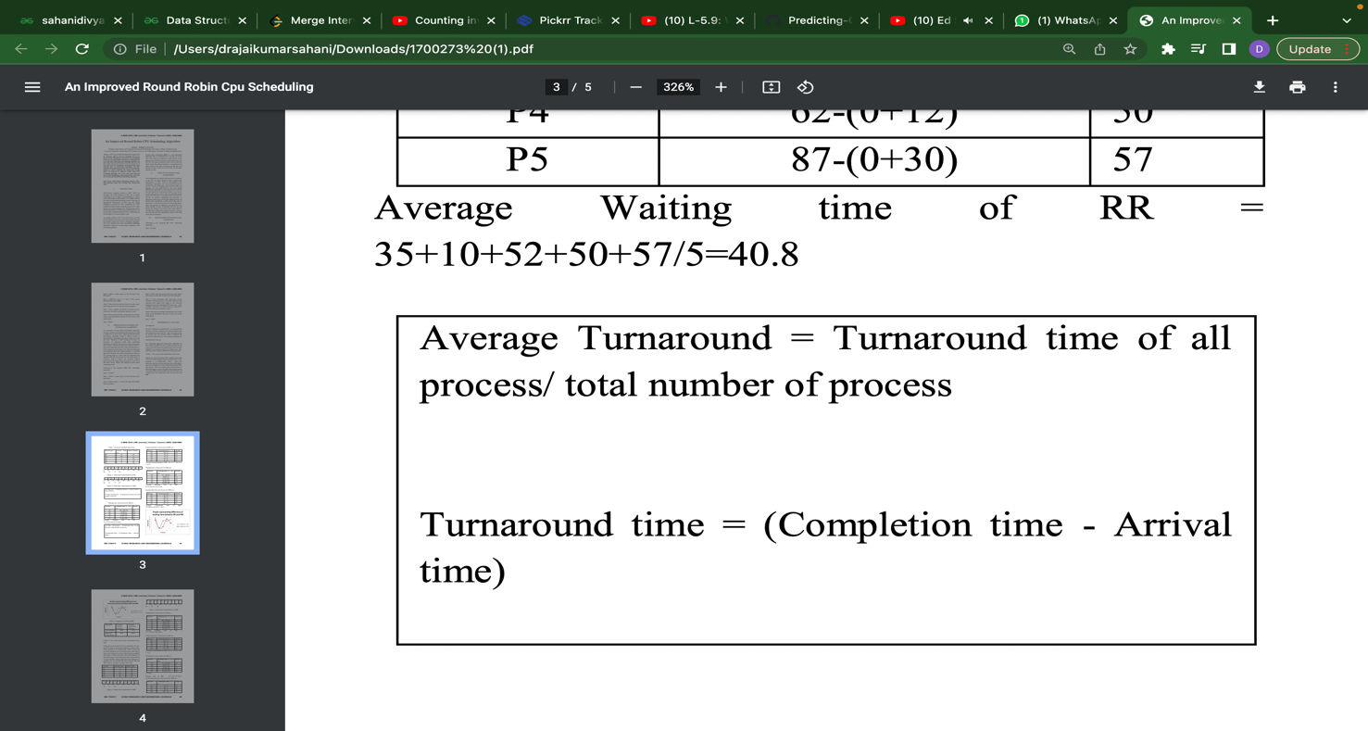

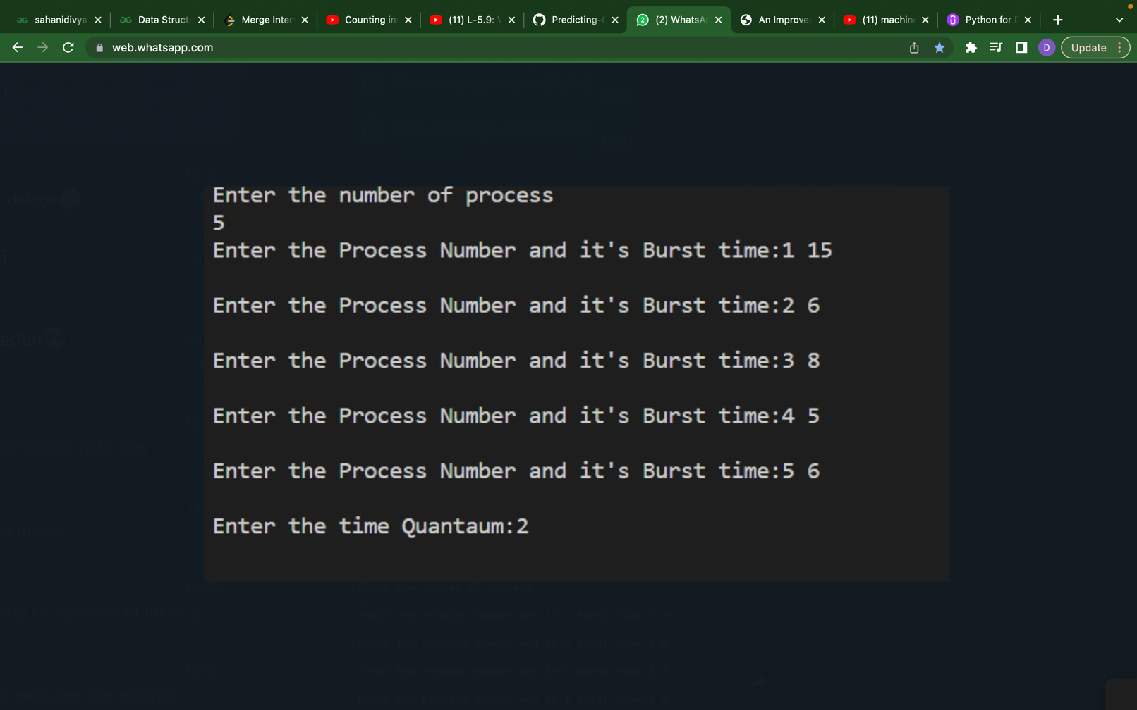

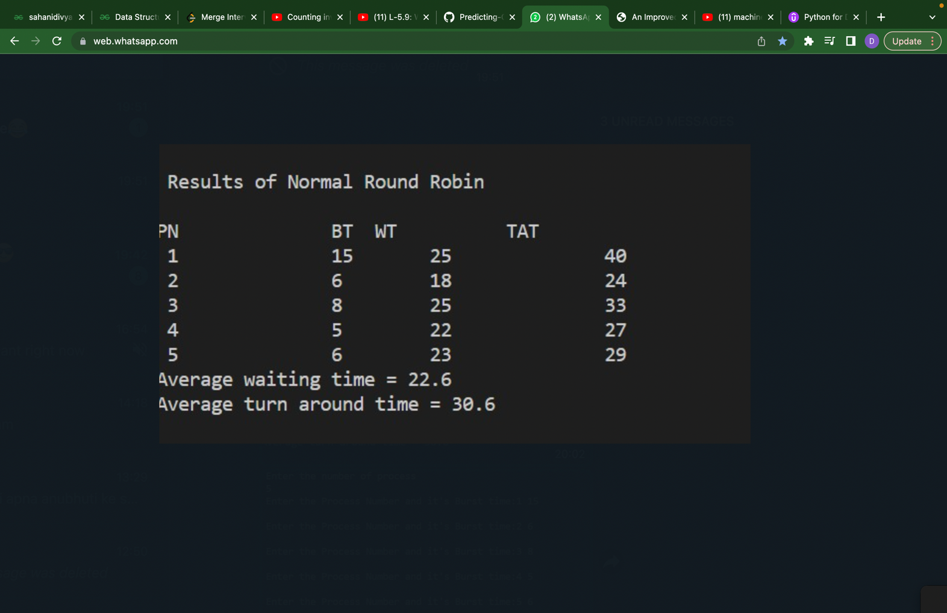

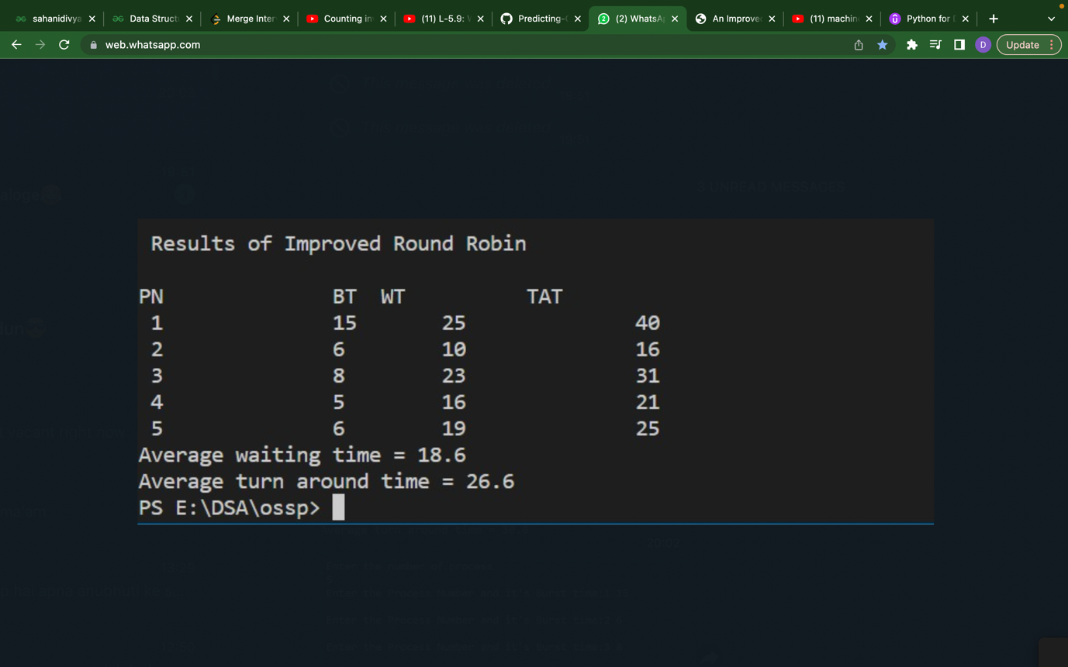

**PROGRAM CODE**

// C++ program for implementation of RR scheduling

#include<iostream>

using namespace std;

// IMPROVED ROUND ROBIN

void findWaitingTime2(int processes[], int n,

int bt[], int wt[], int quantum)

{

int rem_bt[n];

for (int i = 0 ; i < n ; i++)

rem_bt[i] = bt[i];

int t = 0;

while (1)

{

bool done = true;

for (int i = 0 ; i < n; i++)

{

if (rem_bt[i] > 0)

{

done = false;

if (rem_bt[i] > quantum)

{

t += quantum;

rem_bt[i] -= quantum;

if(rem_bt[i] <= quantum)

{

t+=rem_bt[i];

wt[i]=t-bt[i];

rem_bt[i]=0;

}

}

}

}

if (done == true)

break;

}

}

// Round Robin

void findWaitingTime1(int processes[], int n,

int bt[], int wt[], int quantum)

{

int rem_bt[n];

for (int i = 0 ; i < n ; i++)

rem_bt[i] = bt[i];

int t = 0;

while (1)

{

bool done = true;

for (int i = 0 ; i < n; i++)

{

if (rem_bt[i] > 0)

{

done = false;

if (rem_bt[i] > quantum)

{

t += quantum;

rem_bt[i] -= quantum;

}

else

{

t = t + rem_bt[i];

wt[i] = t - bt[i];

rem_bt[i] = 0;

}

}

}

if (done == true)

break;

}

}

void findTurnAroundTime(int processes[], int n,

int bt[], int wt[], int tat[])

{

for (int i = 0; i < n ; i++)

tat[i] = bt[i] + wt[i];

}

void find_avgs(int processes[], int n, int bt[],

int quantum)

{

int wt[n], tat[n], total_wt = 0, total_tat = 0;

findWaitingTime1(processes, n, bt, wt, quantum);

findTurnAroundTime(processes, n, bt, wt, tat);

cout<<"\n\n Results of Normal Round Robin \n\n";

cout << "PN\t "<< " \tBT "

<< " WT " << " \tTAT\n";

for (int i=0; i<n; i++)

{

total_wt = total_wt + wt[i];

total_tat = total_tat + tat[i];

cout << " " << i+1 << "\t\t" << bt[i] <<"\t "

<< wt[i] <<"\t\t " << tat[i] <<endl;

}

cout << "Average waiting time = "

<< (float)total_wt / (float)n;

cout << "\nAverage turn around time = "

<< (float)total_tat / (float)n;

int iwt[n], itat[n], itotal_wt = 0, itotal_tat = 0;

findWaitingTime2(processes, n, bt, iwt, quantum);

findTurnAroundTime(processes, n, bt, iwt, itat);

cout<<"\n\n Results of Improved Round Robin \n\n";

cout << "PN\t "<< " \tBT "

<< " WT " << " \tTAT\n";

for (int i=0; i<n; i++)

{

itotal_wt = itotal_wt + iwt[i];

itotal_tat = itotal_tat + itat[i];

cout << " " << i+1 << "\t\t" << bt[i] <<"\t "

<< iwt[i] <<"\t\t " << itat[i] <<endl;

}

cout << "Average waiting time = "

<< (float)itotal_wt / (float)n;

cout << "\nAverage turn around time = "

<< (float)itotal_tat / (float)n;

}

// Driver code

int main()

{

// process id's

int n;

cout<<"Enter the number of process \n";

cin>>n;

int processes[n],burst_time[n];

for(int i=0;i<n;i++)

{

cout<<"Enter the Process Number and it's Burst time:";

cin>>processes[i]>>burst_time[i];

cout<<"\n";

}

int quantum;

cout<<"Enter the time Quantaum:";

cin>>quantum;

find_avgs(processes, n, burst_time, quantum);

return 0;

}

**RESULTS**

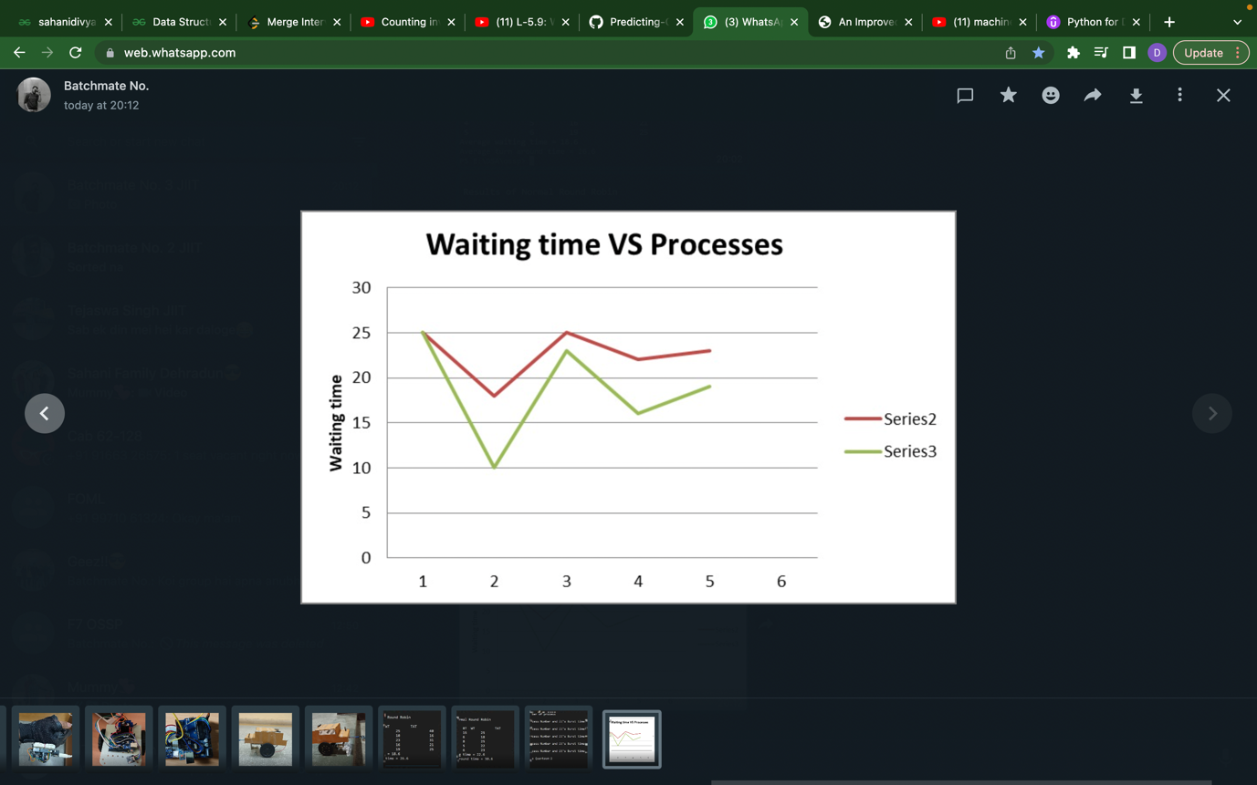

Series 2: Round Robin

Series 3: Improved Round Robin

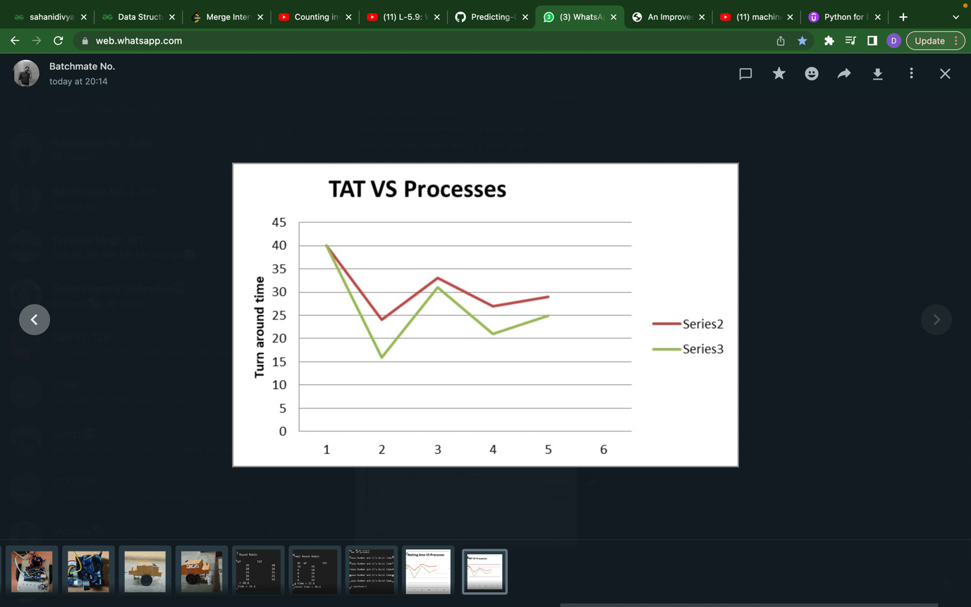

**CONCLUSION**

The allocation of CPU to the processes is one the most important task of the operating system. An improved round robin scheduling algorithm with varying parameters like burst time and time quantum giving better performance than the conventional Round Robin algorithm. The waiting time and the turnaround time have been reduced in the proposed improved round robin algorithm. The proposed algorithm can be implemented to improve the performance of the system. Simulation results also prove the correctness of the theoretical results.

**REFERENCES**

[1]Rakesh Kumar Yadav, Abhishek K Mishra, Navin Prakash and Himanshu Sharma, “An Improved Round Robin Schedduling Algorithm for CPU Scheduling”, International Journal on Computer Science and Engineering, Vol. 02, No. 04, 2010, pp. 1064-1066.

[2]Abbas Noon, Ali Kalakech, and Seifedine Kadry, “A New Round Robin based Scheduling Algorithm for Operating Systems: Dynamic Quantum Using the Mean Average”, International Journal of Computer Science Issues, Vol. 8, Issue 3, No. 1, May 2011, pp. 224-229.

[3]H.S. Behera, Rakesh Mohanty, Sabyasachi Sahu, Sourav Kumar Bhoi, “Design and performance evaluation of multi cyclic round robin(MCRR) algorithm using dynamic time quantum” Journal of global research in computer science(ISSN-2229-371X), volume 2, No.2, February 2011.

[4]Seltzer, M P. Chen and J outerhout, 1990, Disk scheduling revisited in USENIX, Winter technical conference.

[5]A. Silberschatz, P. B. Galvin, and G. Gagne, “Operating System Concepts”, 7th Edn., John Wiley and Sons Inc, 2005, ISBN 0-471- 69466-5.